ELECTRONIC PRESS KIT
About BW
The Blythwood Winds is one of Toronto's most sought after wind ensembles. Founded in 2010, the quintet performs at many of Toronto's musical and cultural venues including the Canadian Music Centre, the Music Gallery, the Toronto Music Garden, and The Art Gallery of Ontario. The Blythwood Winds is deeply committed to the performance of Canadian music. The quintet performed a concert at the Music Gallery in 2015, featuring world premieres by Toronto based composers, including former Toronto Symphony Orchestra Affiliate composer Kevin Lau. This past year, they hosted Hogtown Roundup 2: Toronto Graffiti at Toronto’s Heliconian Hall, premiering new commissioned music by Jason Doell, Elisha Denburg, and Bekah Simms. In 2015, the group was also featured on the Junofest Classical Nominees Showcase presented by CBC Music with the Canadian Music Centre in Hamilton, Ontario.
The Blythwood Winds has an ongoing partnership with the Canadian Music Centre with performances of music by many Canadian composers. The quintet has also been involved with the CMC's OPUS Testing, a co-presentation with Musica Reflecta in which the group premiered pieces for wind quintet and narrator. The Blythwood Winds is featured on the Canadian Music Centre's digital audio archive CentreStreams, with recordings of previously unrecorded works by many CMC Associate Composers.
In addition to its dedication to presenting the works of Canadian composers, the Blythwood Winds is passionate about spreading music to all audiences, performing its own arrangements of different musical genres at many Toronto bars and restaurants.

Timothy Crouch, flute
Elizabeth Eccleston, oboe
Anthony Thompson, clarinet
Kevin Harris, bassoon
Curtis Vander Hyden, horn
Just the Facts
- A group of young Canadian artists committed to sharing music with their community
- Many concerts in partnership with new music organizations
- A wind quintet supporting the commission of new repertoire for this chamber ensemble
Mission Statement
Over the past six years, Blythwood Winds has established itself as a professional chamber ensemble in the city of Toronto.
We seek to:
- Share much-loved repertoire with our audiences
- Promote the composition and performance of new music
- Enrich our community through the exploration of art and culture through music
- Contribute to the high level of musical offerings within the city of Toronto
Blythwood Winds prides itself on its particular passion for the creation and performance of new music.
Selected Favourite Repertoire
- Kevin Lau, Living Miniatures
- Samuel Barber, Summer Music
- Jacques Hétu, Quintette, op. 13
- David Maslanka, Quintet No. 3
- John Williams, Midway March (arr. Vander Hyden)
Reviews
“Blythwood Winds is certainly creating a name for themselves with superb chamber music playing and their dedication to commissioning and performing new Canadian works.” – April 18, 2015 “Blythwood Winds: Hogtown Roundup” (Sharon Lee, Toronto Guardian)*
Photo
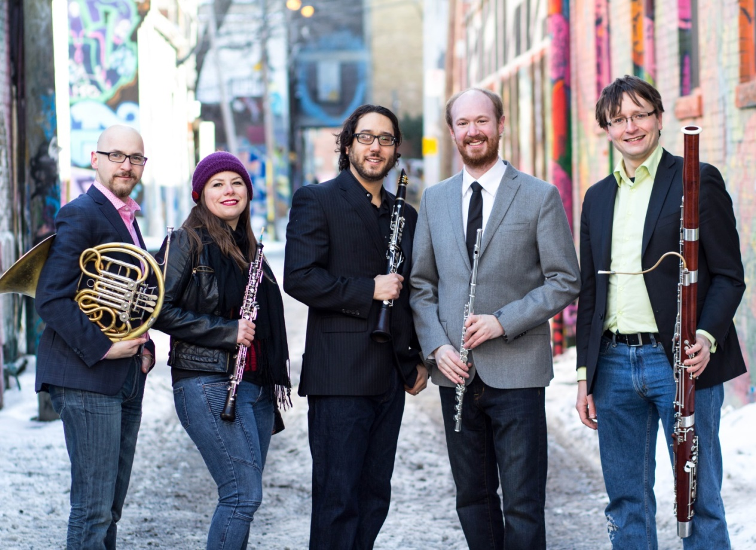

Contact Info

www.blythwoodwinds.com

blythwoodwinds@gmail.com
(*formerly published on Toronto is Awesome)

